STUDENT PROFILE

Enrollment Number: | 003103161080
Name: | MAHEK THAKER
Stream: | BCA
Semester : | SEM-6
Address: | PATEL COLONY NO.9 OPPOSITE RAJ SHAKTI PAN, SHYAM & LAKSHMI NARAYAN TENAMENTS, HOUSE NO.6 JAMNAGAR.
Contact No.: | 8320970771
E-mail: | mahek.haker@gmail.com

PROJECT PROFILE

Project Title : | NITRO FEED RSS READER
Definition Of Application : | Live RSS Feed Reading & Story Browsing
Developed At : | Vidhyasagar InfoTech College Jamnagar
Developed For : | Nitro Feed
Team Size : | 1
Team Member Name : | Mahek Thaker
Internal Project Guide : | Prof. Ram Kevalramani
Platform : | Android Studio 3.0+
Documentation Tools : | Microsoft Word, Paint.
Front End : | ANDROID
Back End: | ADVANCED ANDROID API

PROJECT GUIDE PROFILE

Guide Name : | Prof. Ram Kevalramani
Contact No. : | 9824872679
E-mail : | ramsirforstudent@gmail.com

ACKNOWLEDGEMENT

This project is developed in 2018-2019 to consider the requirement of Rss Feeder and News Reading. I especially thankful to Principal Prof. Ram Kevalramani who has guided me throughout in this project.
I am also thankful to our College, Trustees, Principal, Professors, Teaching and Non-Teaching Staff and Colleagues who have helped and guided me in preparing this project.
I am also thankful to Google Android Documentation and Internet Online library to guide me to develop the project report.
Yours Faithfully,
Mahek Thaker
(Student of BCA SEM-6))

Place: Jamnagar
Date:
ABSTRACT
“NITRO FEED RSS READER”
- AIM OF PROJECT
Project making is a part of BCA The student gets a chance to have practical knowledge of the software exposure as to gain control over programming languages. The objective of practical training of BCA levels is to develop among the students a feeling of software making in order to develop a practical base in them as supplement to the theoretical study of the computer application in general.
Such project making plays a dominant role in developing practical view points, experience and also make them aware about the role situation of the software application.
This project is prepared under my knowledge, guidance given by our professors and especially Thanks to concerned person, who has helped us to get knowledge on the project.
- PROJECT CATEGORY
This project is an ANDROID App project.
PROJECT DESCRIPTION
The objective of this project is to provide latest News articles and ‘RSS’ feed directly retrieved from the main source as faster as possible, from the wide ranges of different areas of the news categories local to international and with the unique user friendly simple UI (User Interface) updates of latest news reach to all is main objective, providing AD-free experience to our users and wide range of news also available in “HINDI” language.
The Feed updates is taken from the RSS feed and special Adaptation for the “ANDROID” platform is processed to make it possible in App, Application uses ‘INTERNET’ to collect the latest news and with very low usage the data is stored.
Application uses various Android APIs and Data Processing and Sorting of Raw data is done Data Retrieved from Rss Feed(which is in Pure XML Format) with help of XMLPULLPARSER API, XML is Parsed and Respective data is displayed to user, one can click on any feed story and read the full article with full details of the story.
Data fetch from RSS Feed is display in different activities and with custom homemade list view control is used to display feed content special adapter holds the feed data and different fragments are used to navigate through app content.

INDEX
1. | Introduction | 10-12
1. | - Project Summary  - Purpose  - Scope
2. | Project Management | 13-15
2. | - Project Planning  - Risk Management System
3. | System Requirement Study | 16-17
3. | - User Characteristics and Software  - Hardware and Software Requirements
4. | System Analysis | 18-22
4. | - Study of Current System  - Problem and Weakness of Current System  - Requirement and New System  - Feasibility Study
5. | System Design | 23-25
5. | - Data Flow Diagram  - Use case  - Gantt chart
6. | Screen Shots | 26-34
6. | - Screen shots Client side
7. | Implementation and Planning Details | 35-38
7. | - Implementation and Environment  - Project Modules Specification  - Coding Standards
8. | Testing | 38-44
8. | - Test methods  - Test cases
9. | Limitation & Future Enhancement | 45
9. | - Limitation  - Future Enhancement
10. | Conclusion | 46
11. | Bibliography | 47

Introduction
- PROJECT SUMMARY:-
The Project Nitro Feed Rss Reader is dedicated to the requirement of the many news readers over the globe where users can read and follow latest news stories and articles based on their interest.

With the wide range of available feeds which are divides in respective categories users can easily browse any feed and follow up on it.

The main objective of the project is to improve the user experience efficiency facilitating it to promptly address any kind of information sought for and to minimize complexity.

Hence this Application is used to maintain working detail in the Nitro Feed Rss Reader thus the user get better response with it.

Hence this Application is used to providing good service to the Let Users
Access fast news reaching to them and use our services.

Users are always invited to join the beta program of the Application and provide their valuable feedback and improve the User Interaction and enhance the Application features.

PURPOSE OF PROJECT
Purpose of the project “Nitro Feed” is to provide latest and fast news feed to their users with the Advertisement free User Interface with our wide range of News and Rss Feed related services we provide better way of reading news under project “Nitro Feed Rss Reader”.

The Project Nitro Feed Rss Reader is dedicated to the requirement of the many news readers over the globe where users can read and follow latest news stories and articles based on their interest.

Hence this Application is used to providing good service to the Let Users Access fast news reaching to them and use our services.
SCOPE OF PROJECT:-

Breaking a problem into successively manageable parts for individual study. Every application development project should begin with an analysis of the requirements and clear list of goals. The basic aim of analysis is to obtain a clear understanding of user’s needs & what exactly is desired from the software, and what constraints on the solution are.
- SOFTWARE USED
1. Android Studio

PROJECT MANAGEMENT
The manager who forgets that software engineering work is an intensely human endeavor will never have success in project management.
A manager who fails to encourage comprehensive customer communication early in the evolution of a project risks building an elegant solution for the wrong problem.
Finally the manager who pays little attention to the process runs the risks of inserting competent technical methods & tools into a vacuum.
Project Management has two parts like:
- Project Planning & Scheduling
- Risk Management

- PROJECT PLANING AND SCHEDULING
The software project management process begins with a set of activities that are collectively called Project Planning.
The first of these activities is Estimation. Whenever estimates are made, we look into the future and accept some degree of uncertainly as a matter of course. Although estimating is as much art as it is science, this important activity need not be conducted in a random manner. Useful techniques for time & effort estimation do exist. And because estimation lays a foundation for all other project planning activities, and project planning provides the road map or successful software-engineering.

Project Planning Objectives:
- Software Scope
- Resources

RISK MANAGEMENT
Although there has been considerable debar about the proper definition for software risk, There is general agreement that risk always involves two characteristics:
Uncertainly: -
The events that characterize the risk may or may not happen.
i.e. There are not 100% probable risk.
Loss: -
If the risk becomes a reality unwanted consequences or loses will occur. When risks analyzed it is important to quantify the level of uncertainly and the degree of loss associated with each risk. To accomplish this, different categories of risk are considered.

Category of Risk:
1) Project Risk
2) Technical Risk
3) Business Risk
Types of Risk:
1) Product Size Risk
2) Business Impact Risk
3) Customer Related Risk
4) Process Risk
5) Process Issues
6) Technical Issues
7) Technology Risk
8) Development Environment Risk
9) Risk associated with staff size and Experience.

SYSTEM REQUIREMENT

It Studies the current business system to find out how it works and where improvement should be made? This study consider both manual and computer methods.
A requirement is a feature that must be include in a new system it may include a way of capturing or processing data, producing information, controlling a business activities or supporting management.
- CHARACTERISTIC OF SOFTWARE
1) Predetermine objectives
2) Set of Component
3) Set of Process
4) Inter related and Interdependence
5) Sub System
6) Integration

- SOFTWARE REQUIREMENTS
ANDROID STUDIO
- HARDWARE REQUIREMENTS
Intel Core Processor / AMD
4 GB RAM
500 GB Hard disk or onwards
SYSTEM ANALYSIS

- STUDY OF CURRENT SYSTEM
We have done detailed study about the existing system and we found following fact. All the works such as administration maintenance ware performing manually. Some services were computerized but they have not proper and complete website for maintenance their works.
We find that there was a need of computerized system to maintain that works.

- Problem & Weakness of Current System
The Preliminary Investigation starts as soon as someone either a user or a member of a particular department recognizes a problem or initiates a request, to modify the current computerized system, or to computerize the current manual system. An important outcome of the preliminary investigation is determining whether the system requested is feasible or not.
The major purposes of this study are listed below:

- Requirement of New System
There are two specific groups of end-users:
Those who uses the system. In this case the End-Users and Officer who actually comes in control activity.
Those affected by the inputs and outputs of the system in study. In this case the management who decides the schemes given to user, the slip amount taken from the staff is involved.
To develop the initial scope of the system we need to get a broad idea of the system in study. In this case we can identify the main process as ‘to get the details of the Staff, Trainee and other aspects’, which gets the input from each fault maker. The output of the system is also sent back to the respective staff and branch Office.

Feasibility Study
Feasibility is the determination of whether or not a project is worth doing. The process followed in making this determination is called a feasibility study. This type of study determines if a project can and should be taken. Once it has been determine that project is feasible, the analyst can go ahead and prepare a project specification, which finalizes project requirements.
In the conduct of the feasibility study, we usually consider seven distinct, but inter-related types of feasibility. They are:
        - Technical Feasibility
        - Economic Feasibility
        - Operational Feasibility
Technical Feasibility
The Technical needs of the system are as follows:
    - Facility to communicate data to distant location.
    - Response time under certain conditions.
    - Ability to process a certain volume of transaction at a particular speed.
In examining the technical feasibility, configuration is given more importance than actual make of hardware. Here the configuration gives the complete picture about the system’s requirements:
- How many workstations are required?
- How these workstations are interconnected so that they can operate and communicate smoothly.
- What speeds of Input and Output should be achieved.
As the above requirements of the system can be fulfilled easily with the technology available in the market, therefore the proposed system is technically feasible.
Economic Feasibility
Economic analysis is the most frequently used technique for evaluating the effectiveness of a proposed system. More commonly known as Cost/Benefit analysis; the procedure is to determine the benefits and savings that are expected from a proposed system and compare them with the costs. If benefits outweigh costs, a decision is taken to design and implement the system. Otherwise, further justification or alternative in the proposed system will have to be made if it is to have a chance of being approved.
Proposed system for Amway Cosmetics is economically feasible in terms of time and effort of staff and management. Cost will be incurred at the beginning but the effort and time saved by the proposed system far outweighs the cost incurred. Since the classes is not already computerized, so initially large amount will be involved but in due course with the outcome of the system, the cost will be outweighed by the result of the automated system.
Operational Feasibility
It is mainly related to human company and political aspects. The points to be considered are:
    - What changes will be brought with the system?
    - What company structures are distributed?
    - What new skills will be required?
Project is not rejected simply because of operational infeasibility but such consideration is likely to critically affect the nature and scope of the eventual recommendations.
For Amway Cosmetics products Center apart from other facts as per operational feasibility is concerned we need to see to it that the system to be developed should be user-friendly so that staff and other personnel’s who are not computer literate find it easy to work with. As the office staff does most of the work, so they might have to be trained.
SYSTEM DESIGN
Dataflow Diagram:
0 Level DFD

Free
Listing

Read Trending Stories

Read Feed in Various categories

Nitro Feed

App Idea

Hindi Feed

Read Full Article in Detail

Use case

Splash Screen

Trending Stories
End User

Feeds in Categories

Hindi Story Feed

Read Full Article

Update Feed
Settings

About Project

Gantt chart
Month | 1-30 Nov |  |  |  | 1-31 Dec |  |  |  | 1-31 Jan |  |  |  | 1-20 Feb
Weeks | 1 | 2 | 3 | 4 | 1 | 2 | 3 | 4 | 1 | 2 | 3 | 4 | 1 | 2
Tasks

Understanding
The System
Analysis Of
Requirements
Database And
GUI Designing
Coding And
Testing
Final Documentation
Learning
Process

Screenshots
Trending Stories
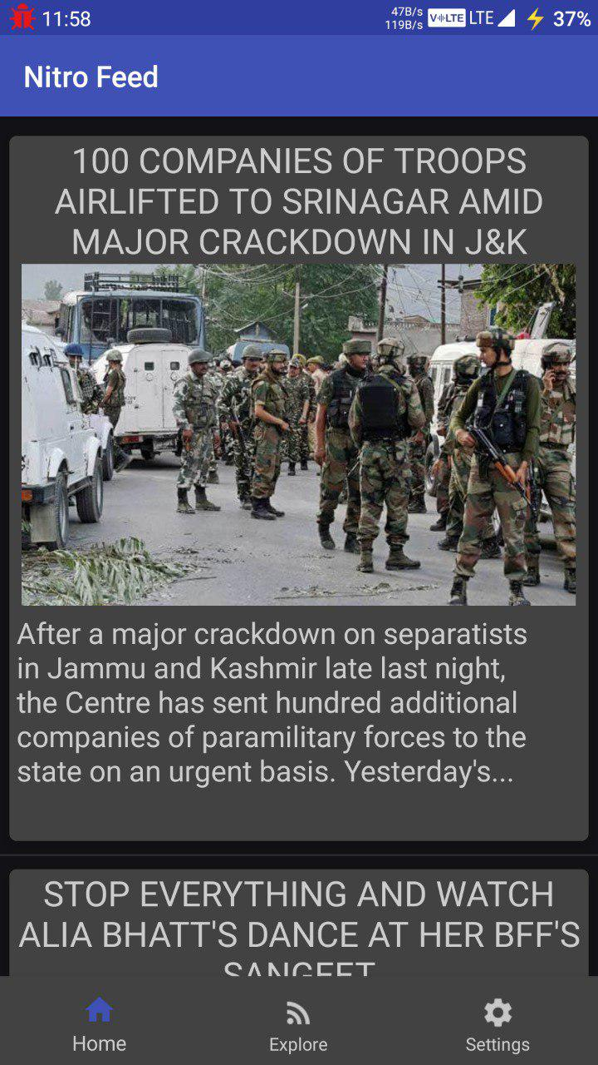
Explore Feeds

Read Full Story
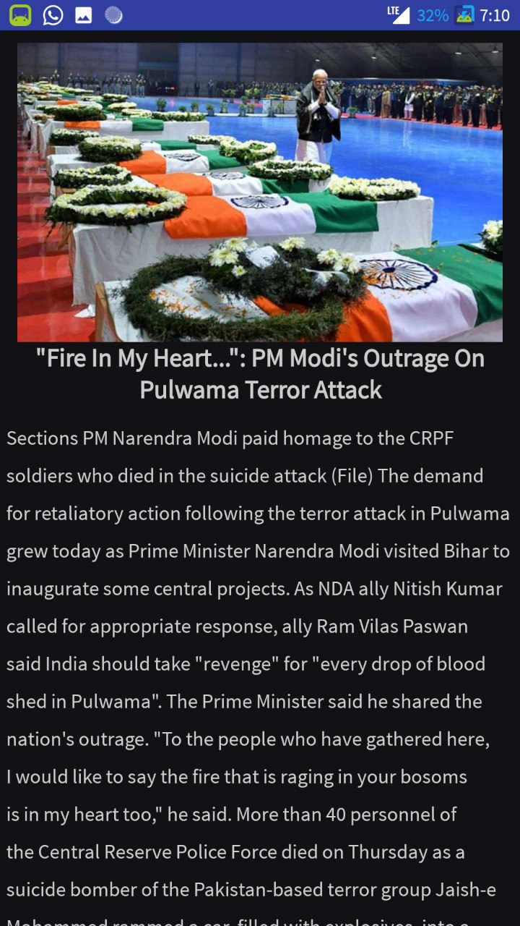
Hindi Feed
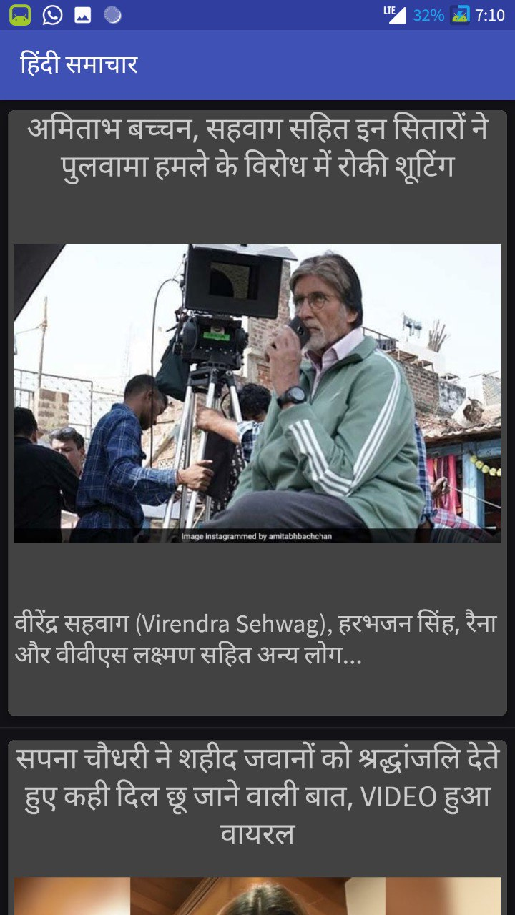
Splash Screen

Settings
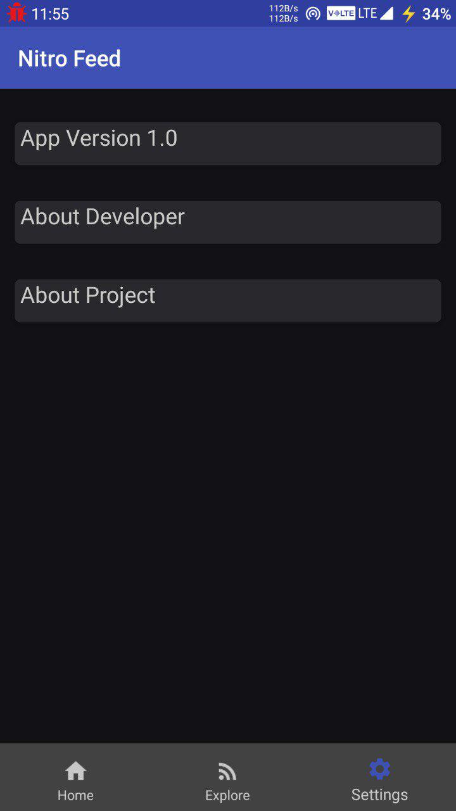
About Developer
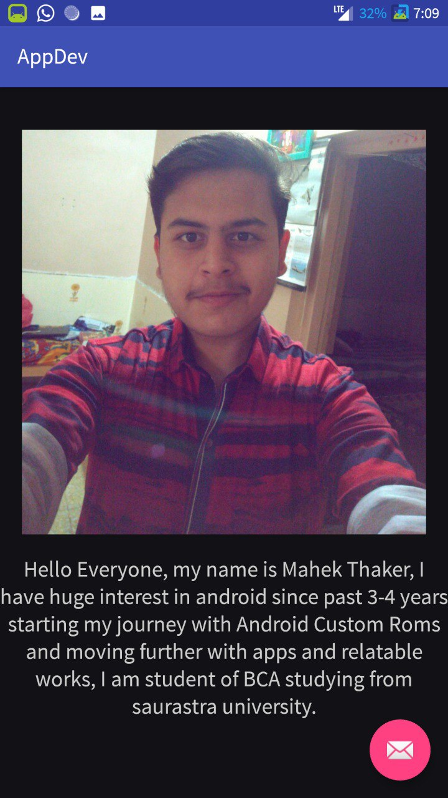
No Internet

Process
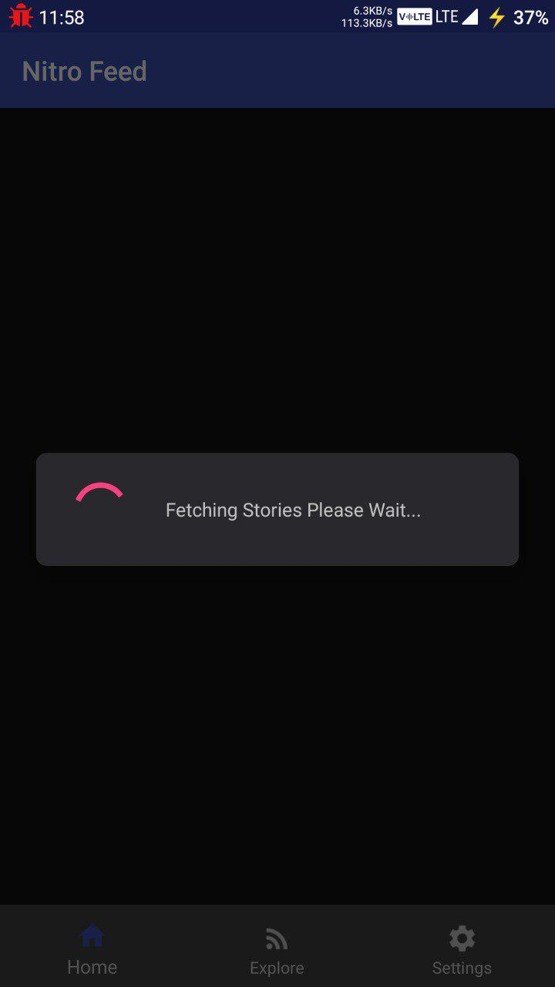
IMPLEMENTATION AND PLANNING DETAILS

- IMPLEMENTATION AND ENVIRONMENT
Implementation is a phase where a number of activities that have been going on parallel so far have to culminate. To ensure that all these activities indeed converge at the right time and at the right place without any delays on account of unforeseen problems, to get the software to be used at is should, is what managing the implementation phase is all about the steps involved are:

Installation Plan: Much before the software could be actually ready; a detailed plan has to be prepared in terms of hardware, procurement and installation. What machines are to be installed at which location and at what point in time, provision of the necessary infrastructure for installation of the same, site preparation, arranging any machines specific or commodity software specific training for different categories of users etc. are details which would need to be worked out. Likewise a plan has got to be mad for installation of the software to be implemented. Details of which modules are to be Enabled/Disabled in each location have to be worked out. Therefore a comprehensive installation plan needs to be in place, which gives location wise installation details as relevant to different user groups.

So, for ‘News’ and ‘RSS’ Feed service provided by Nitro Feed Rss Reader services an implementation plan was prepared at the right time. Data Preparation and Conversion: Assuming that the system is expected to go live from a particular date, all backlogs of data has to be transcribed to fit into the new formats and coding schemes and rigorously errors are checked to ensure no loss of information.

For Online News & Rss Feeder services all the existing REGARDING works and others was fed into the system, as the details of the users of Nitro Feed Rss Reader is to be maintained old records also apart from the fresh data.
Conversion Testing: Where data is converted from existing files or databases, rigorous conversion testing needs to be done to ensure proper conversion.
The following steps testing were performed as a part of conversion for “Nitro Feed Rss Reader”.
Tallying of input and output record.
Extraction of sample records from both the old and new set of records. This are then directly compared with each other.
Check value ran fields within each record.
Check whether the required relationships between records are maintained.

User Training: The successful implementation of any software is depend in good measure on the quality of training imparted. Different user groups need to be identified. A training need analysis has to be done for each of these groups to find out what kind of training is required for each. Getting trained on aspects that are not relevant may sometimes tend to confuse the users.

Security Measures Taken: Security and controls are required not only for preventing in inadvertent mistakes made by users, but also to prevent misuse of the system and ensure data integrity.
In an automated system Nitro Feed Rss Reader application the following security measures have been considered:

- PROJECT MODULE OF NEW SYSTEM
The following tables are structure is used to develop Nitro Feed Rss Reader
- User feeds
- Background Activities
- Live Feeding

- CODING STANDARD
Access Control:
The Access Control can be defined as control established to ensure that only administrator is accessed with the proper authority. Different types of access control, which are used in this software, are as follows:

Physical Access:
The best form of access control is the physical access control. Only authorized person should be allowed to do specific tasks like booting of the machine, mounting disk, distributing reports etc.

Validations:
Validations of data entered on various input screens are not a security for the system but a control to ensure that clean data goes into the system. If data is not validated on input, you will end up with a lot of inconsistent data.

Length of Data:
Type of data (numeric, integers, alphabetic, alphanumeric), Discreet values, Cross validation of data across various fields.

Data Integrity:
We can have the best of validation in a system but invalid data can always get into the system due to some recent changes done on the software, which was not tested comprehensively, of due to corruption.

Security Features:
In the Nitro Feed Rss Reader, we have set the best security feature to operate the application, when user first interacts with the Application checks for the Internet Connectivity & it will check both Mobile Data & WIFI connection, if user have disabled Internet to then application will display to the user No Internet Connection Error Page, this system called “Connectivity Detector”.
Testing

The word “test” is derived from the Latin word “tested” meaning pottery vessel used to measure and access weight. The testing of software is a means of accessing or measuring the software to determine its quality. Testing is done with one primary objective- to ensure the quality of software before live operations. Testing involves operation of a system or application under controlled conditions and evaluating the results. In the development of automated system for Products, we have applied the following testing techniques and testing Strategies.
- Testing Plan:-
- White - Box Testing

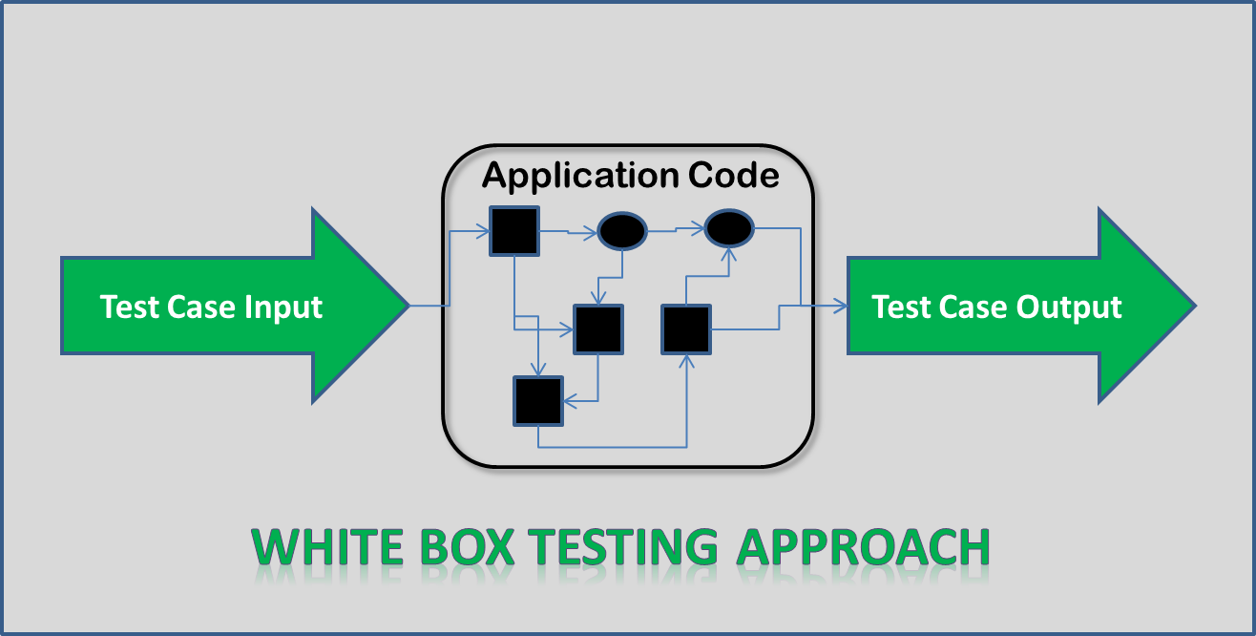

- White – Box
- Guarantee that all independent paths within a module have been exercised at least once.
- Exercise all logical decisions on their true and false sides.
- Execute all loops at their boundaries and within their operational bounds.
- Exercise internal data structures to ensure their validity.

- Black Box Testing
Try different inputs and see if we get the correct output:

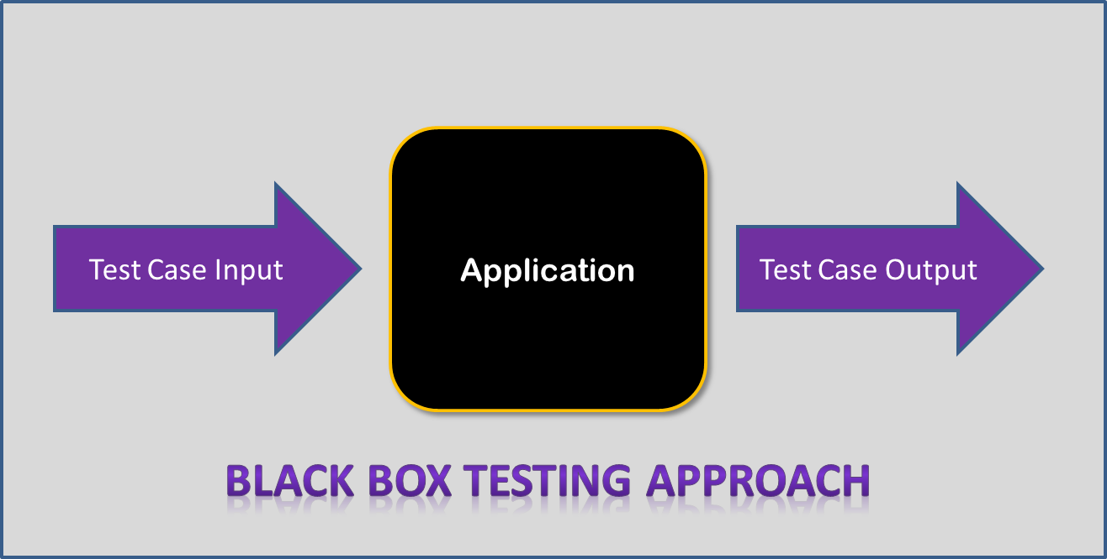 Black Box
- Black Interface Errors
- Errors in Data Structures.
- Performance
- Initialization Errors
- Boundary value testing.
- Testing Strategies:-
- Unit Testing
Unit testing, also called module or component testing is testing individual software units independently of the other units in the same system. The programmer does this testing. Unit testing is recognized as one of the most efficient ways to reduce the density and proliferation of errors in a software application. Unit testing has been done for each ITEM of the system. We have followed the following procedure to perform unit testing:
  - Identified the scenarios for each action in all the screens.
  - Tested main method in each screen to invoke that screen.
  - Tested the output for all the possible combination of input values and user actions.
  - Examine the result of each user action.
Test Method:-
Identification of the test units:-
The system “Nitro Feed Rss Reader” has been broadly classified in the following units so that the unit testing can be performed efficiently. The units identified as login module, the main form module contains main menu, pre-service module, in–service module curriculum and evaluation module, working experience module, Feed reading with the Reading full article module, and some other sub-module: Feeder module etc.
The feature of the above identification modules are to be tested individually so that all the errors in those modules can be found and corrected.
Features to be tested:-

- Check internet Connectivity.
- Check each module attached in main menu module.
- Check each module work well.
- Check all the button work well
- Check each view is worked in efficient manner.
- Check any module cannot operate inefficient manner
- Check Is it work in efficiently in the Application.
- Check its error tolerance

TEST CASES:-
In different terms and condition, it was find the system “Nitro Feed Rss Reader” is enable to solve the entire problem related to Browsing Live Rss Feed and Reading full news articles in details.
Is Internet Connected?
If Internet Connectivity is there then a massage as “Welcome to the Nitro Feed” will be displayed in the Main page.
All the modules are connected properly with main menu.
This can be displayed on the status bar. Where the entire module can be shown. Implementing the test plan in the software with data.-
There are two methods are used for implementing the test plan.
      - Testing with the dummy data: - Testing in this way means testing with data which not original or it is dummy. With this method accuracy of the system can be judged according to some extents. If the system is running correctly with this data then it can be inferred that software has been tested successfully.
      - Testing with Live data: - Testing with live data means testing with original data. This means that system is tested with data taken from the actual user. This is very accurate as compared to dummy data. If the system is running correctly with this data then it can be inferred that software tested successfully.

The Some CASE with Expected Behavior and Observed Behavior:
CASE-1 : Open Application without Internet Connection.
Expected Behavior : Should show “No Connection”.
Observed Behavior : Moved to “No Connection” Page.

CASE-2 : Open Application with Internet Connection.
Expected Behavior : Should display the ‘Welcome screen’ and
Then display the Live Feeds are loaded.
Observed Behavior : Display the ‘Welcome screen’ and then
the Live Feeds were loaded.

CASE-3 : Select Pre service from the
Visit main menu.
Expected Behavior : Should display the screen and also
Display its content.
Observed Behavior : Display the screen and select any
Option to using it.

CASE-4 : Select any option.
Expected Behavior : Should display the related form.
Observed Behavior : Display the form and we found all the
Input box is enabling.
LIMITATION & FUTURE ENHANCEMENT

- Limitation :-
- This Application Don’t have Light theme.
- Users cannot add new news source.
- Live tv is not there.
- Sharing link of stories not available.
- Future Feature Enhancement:-
          - We will add Dark/Light themes toggle support.
          - We will provide Live TV Support.
          - We will also provide Link sharing of feeds and Articles.

Conclusion of the Project
The main purpose of this Project is to provide free Live Rss feed and article reading service to the end users and the detailed feed reading feature provided by Nitro Feed Rss Reader. The meaning of making Rss feed reader is that, at current time Reading Rss feed with wide range of options and Hindi support is not totally free has no any other Applications to maintain Feeds and provide free file feeds services on Android Platform.
And the future scope of this Application is very good and easy on the basis of changing of objective and analysis report. The future scope of this project is listed below.

Security: - Data is secure. Only the App Developer can do changes and update source of raw data.
Large Database Supports: - Using SQLITE SERVER as RDBMS means large number of records can be managed without facing any problem.

Bibliography
The Bibliography contains references to all the documents that were used to develop the software/website.
Books
Mobile Computing Using Android & IPhone

Websites
www.youtube.com
www.github.com
www.developer.android.com
www.stackoverflow.com

Search Engine
www.google.com

